|  |  |  |
| --- | --- | --- |
|  | **250th Anniversary of the Battles of Lexington & Concord** |  |

The activities outlined below are intended to educate the youth about the history of one of the earliest events of the American Revolution. This document serves as an outline for instructors and youth leaders to plan their own programs with an American Revolution theme. It is by no means a comprehensive list and you are encouraged to add or modify events as needed.

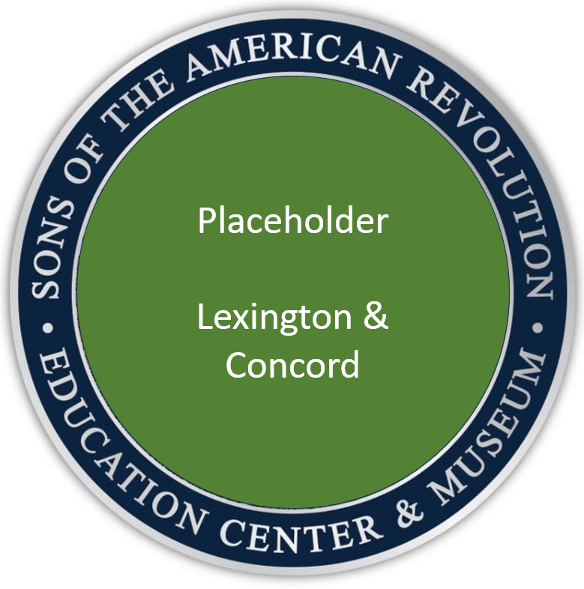

**Sample Event Coin/Pin/Patch**

**Background:** Escalating tensions between the colonists and the British government reached a critical point in early 1775. Following the Boston Tea Party protest of British taxes and unjust laws in December 1773, Parliament responded by passing the Intolerable Acts – harsh and restrictive measures that further limited the rights of their American subjects. In September 1774, the colonies sent delegates to the First Continental Congress, which moved to boycott trade with Britain, declared their rights as English citizens, called for the repeal of the Intolerable Acts, and encouraged each colony to train its militia and stockpile gunpower and ammunition. Increasingly concerned about the militia build up, royal governors and the British Army attempted to seize these stockpiles. On April 19, 1775, 700 British regulars left Boston on a mission to capture military supplies stored by the Massachusetts militia at Concord. Alerted to this action, minutemen converged in Middlesex County to stop the British advance. Shots were fired, and the American Revolutionary War began.

**Activities**

**Network of whispers:** In February 1775, the British government declared Massachusetts to be in a state of rebellion and sent the British Army to occupy the town of Boston. Both the American rebels and the British Army established networks of informants and spies to gather intelligence on the plans and actions of their adversaries.

***Secret Code***: Decode the message about the plans of the British! The activity and its answer key can be found at the end of this packet.

***************************

**Join the Cause:** Colonists joined the militia – and later in 1775, the Continental Army – for many reasons, both political and personal. It was a difficult decision for many because they knew they would be away from their families, put their farms or businesses at risk, live and march in challenging conditions, and possibly die from disease, imprisonment, or combat.

***Convince Your Neighbor***: Make your case to your fellow group members about why they should join the militia or support the rebellion with food or supplies:

* Write a “pamphlet” explaining your position. Recommend at least 100 words for 3rd grade and younger, and 200 words for 4th grade and older.
* Write a short speech and deliver it in the “town square.” Recommend at least 100 words for 3rd grade and younger, and 200 words for 4th grade and older.
* Make a recruiting poster or newspaper ad to convince people to join the cause.
* For a modern twist, have students design a social media post, recruiting video, or podcast segment to make their case!

***************************

**Midnight Ride:** Upon learning of the British Army’s intention to seize supplies at Concord, Paul Revere and William Dawes famously rode out of Boston to warn nearby towns to call up their militias. They were joined by Samuel Prescott near Lexington, who was the only one of the three men to reach Concord (Revere was captured, and Dawes’ horse gave out). Throughout the war, other riders we instrumental in warning the colonists of British attacks, including Sybil Ludington, the sixteen-year-old daughter of a militia colonel who rode 40 miles the night of April 26, 1777 to muster troops for the protection of Danbury, CT.

***Relay the News***: Run a relay race by dividing your group into teams and setting up several stations to perform tasks, which might include:

* Crossing the Charles River – carry a cup or bucket of water from one station to the next without spilling it.
* One if by Land, Two if by Sea – turn on a flashlight to “signal the militia from the Old North Church.” For an added challenge, place this station at the top of a flight of gym stairs or on outdoor playground equipment (jungle gym, slide, etc.)
* Deliver the Report – at this station, write the phrase “The British Army marches to Concord on April 19” on a piece of paper, place this “report” in a sealed envelope, and deliver it to the next station.
* Pitch Black – to simulate saddling your horse in the dark, put on a blindfold and tie three different lengths or rope or string around a post or another object. The next person in the relay can put on the blindfold and untie the knots.
* Paul Revere’s Ride – at the final station, place a copy of Longfellow’s poem [*Paul Revere’s Ride*](https://poets.org/poem/paul-reveres-ride). Divide the poem into equal sections for each team member and have each participant in the relay read their section in a loud, clear voice, as though they were calling out the militia!
* Or create your own!

***************************

**Shot Heard ‘Round the World:** On the morning of April 19, 1775, about 80 militia men from Lexington had responded to the call to muster and were gathered on the Lexington common led by Captain John Parker. The first of 700 British soldiers in Col. Francis Smith’s column to arrive were led by Major John Pitcairn, who attempted to surround the militia and instructed them to lay down their arms. History does not clearly record which side fired the first shot, but in the ensuing skirmish, eight Lexington men were killed and the militia dispersed. Reforming his troops, Major Pitcairn continued his march to Concord, where the British troops commenced their search for military supplies. Militiamen from Concord and nearby towns gathered outside of town. With about 400 men led by Col. James Barrett, they engaged a British force guarding North Bridge and drove them off. Emptyhanded, Col. Smith began his return march to Boston at midday, and was ambushed and harassed continually on the 25-mile trek by 4,000 militia who responded to the alarm, suffering 300 casualties (killed, wounded or missing). By the morning of April 20, 15,000 militiamen had surrounded the town of Boston.

***To Arms!***: In a modified version of “Capture the Flag,” place small boxes or containers representing gunpowder barrels or military supplies around an outdoor or indoor playing field. Divide the playing field into two “home” areas for each team and have each team attempt to retrieve supplies from the opposing territory. If a person is tagged by an opposing team member while in the opponent’s territory, that person must freeze in place until tagged again by a friendly team member. At the end of a designated time period, the team with the most supplies is declared the victor!

***************************

# Interactive Experiences

**Patriot Chest Presentations:** Your local SAR Chapter would enjoy visiting your classroom or youth group at any time of the year to deliver a Patriot Chest presentation. The Patriot Chest is filled with many items that American colonists and Revolutionary soldiers used in everyday life. SAR members often present in uniform and take an interactive, hands-on approach to discussing events of the American Revolution.





# Commemorative Event Coin / Pin / Patch

Your organization may order a coin, pin or path to commemorate the 250th Anniversary of the Battle of Lexington & Concord and recognize your youth for completing the recommended activities. The SAR recommends that youth complete at least 3 activities, or 1 interactive experience and 1 activity, as a means of earning this recognition

For information on ordering, please email [Lorie@abemblem.com](mailto:Lorie@abemblem.com) at A-B Emblem to get a custom price based on the number ordered. There is a 50 piece minimum order.

