How To Use These Certificate Formats

The NSSAR has a lot of certificates that you can order. All of them you will need to add the name of the individual to personalize the award. Those who are responsible for printing the certificates already know how to add names. Here we will take it a step further, by also adding the new America 250 SAR logo to the certificates. Below are three samples. First, we show you what the final certificate is to look like. Next, we supply you with templates in Word to use. Make up your own certificates using the Blank Certificates that you buy from National and use the examples below.

Blank Certificate | 250 Award Certificate | Flag Certificate
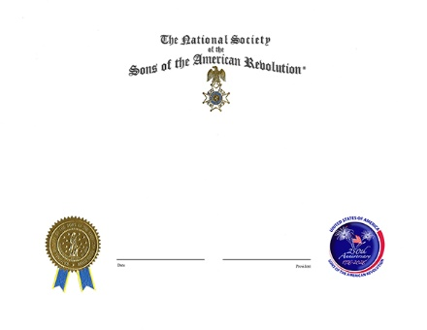 | 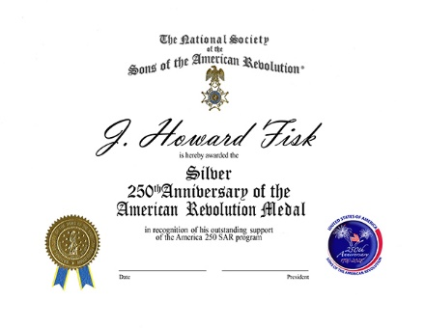 | 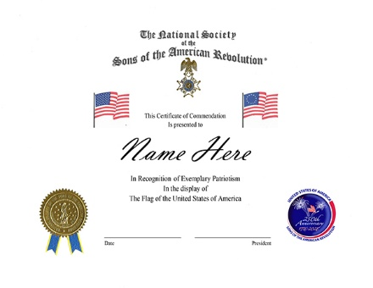
For this Blank Certificate with both logos, buy the standard Blank Certificate from NSSAR and print the 250 logo on the lower right in color. See the format page A following. | For this Awards Certificate with both logos, buy the standard Blank Certificate from NSSAR add the name and info and print on the existing certificate. The font of the person’s name is 72pt. Vladimir Script, the award large text is 36pt.Old English Text M, and the smaller text is 16pt. Times New Roman See the format page B following. | For this Flags Certificate with both logos, buy the standard Blank Certificate from NSSAR add the name and info and print on the existing certificate. Main text is 16pt. Times New Roman font of the person’s name is 72pt. Vladimir Script. See the format page C following.
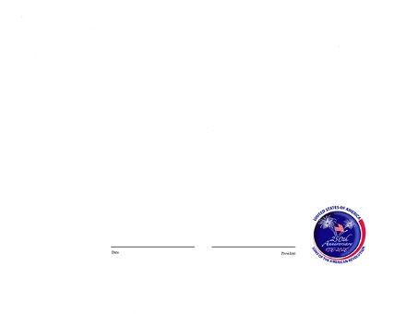 | 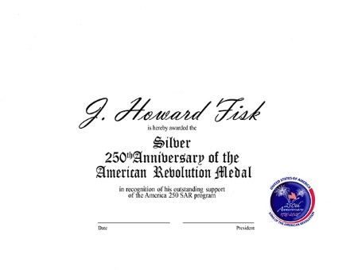 | 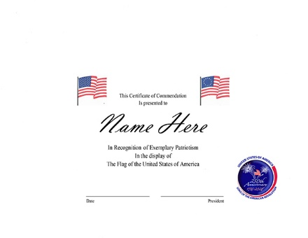

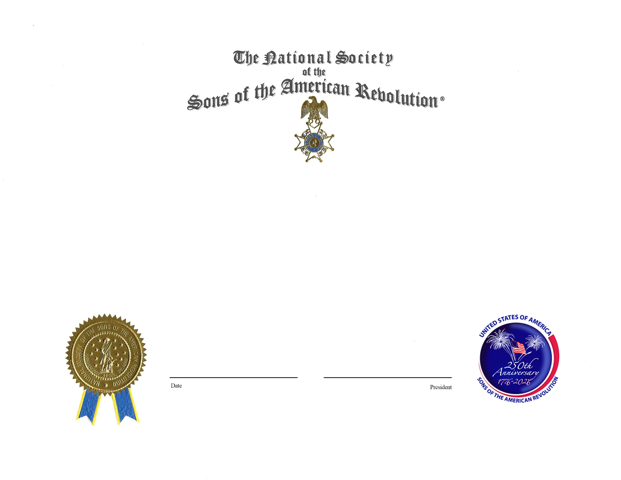

Date President
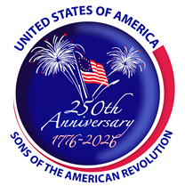

Date President

is hereby awarded the

Silver

250thAnniversary of the
American Revolution Medal
in recognition of his outstanding support
of the America 250 SAR program

J. Howard Fisk
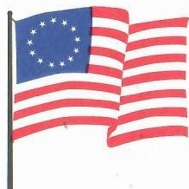
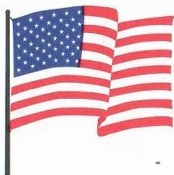
Name Here

This Certificate of Commendation

Is presented to

In Recognition of Exemplary Patriotism
In the display of
The Flag of the United States of America

Date President

