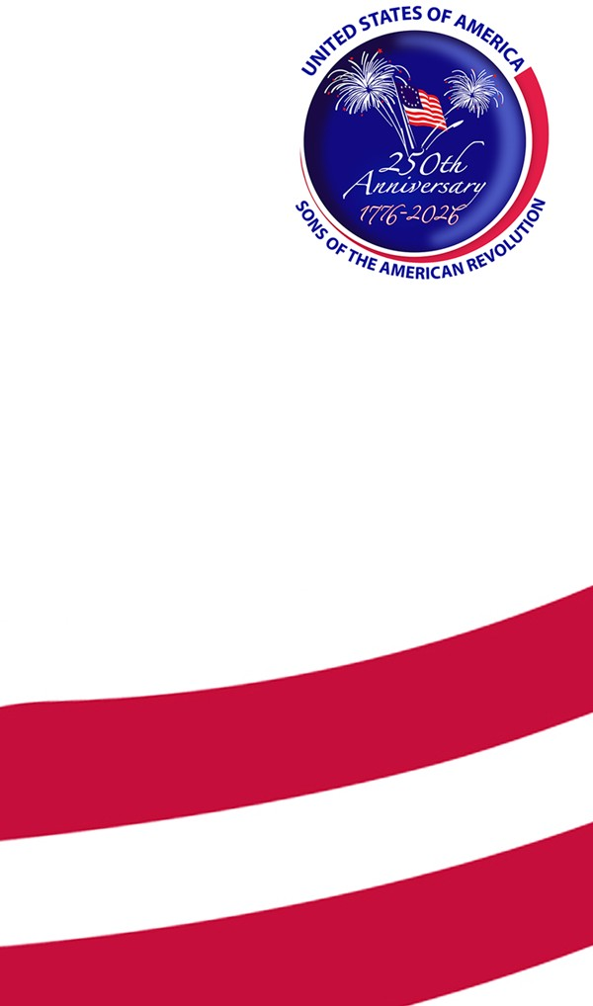

J. Howard Fisk

America 250 SAR Committee

Missouri

417.862.5285

[jhoward@fisk.limo](mailto:jhoward@fisk.limo)