|  |  |  |
| --- | --- | --- |
|  | **250th Anniversary of the First Continental Congress** |  |

The activities outlined below are intended to educate the youth about the history of one of the earliest events of the American Revolution. This document serves as an outline for instructors and youth leaders to plan their own programs with an American Revolution theme. It is by no means a comprehensive list and you are encouraged to add or modify events as needed.

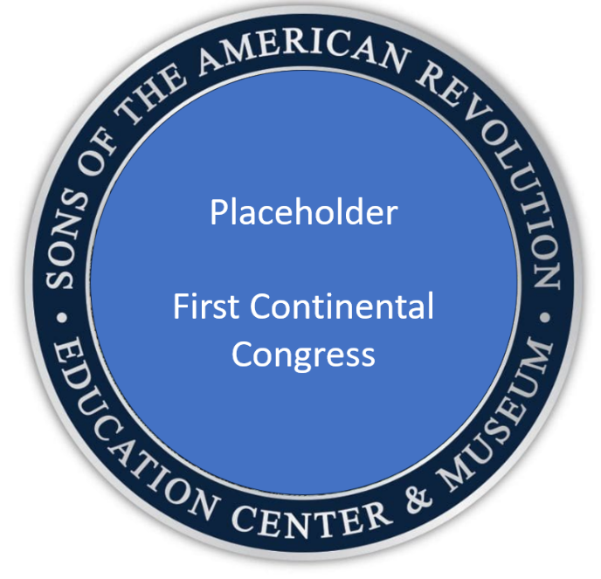

**Sample Event Coin/Pin/Patch**

**Background:** On September 5, 1774, fifty-five delegates from twelve British colonies met in Philadelphia to discuss a coordinated American response to the Intolerable Acts – four laws enacted by the British Parliament to punish the colonists for the Boston Tea Party. Over the course of 51 days, the First Continental Congress debated the alternate paths of reconciliation with Britain and independence for America. They enacted the Articles of Association, which initiated a boycott on trade with Britain in all colonies, and published the Declaration and Resolves, which listed a colonial bill of rights and detailed colonial grievances in an important prelude to the Declaration of Independence.

**Activities**

**In Congress Assembled:** For most of their history, each of the 13 colonies acted separately from the others in pursuit of their own self-interest, competing for trade opportunities and arguing over colonial boundaries. At the First Continental Congress, colonial delegates were presented with the difficult challenge of finding common ground and learning how to work together for their mutual benefit.

***Cooperation:*** As a group or in teams, work together to achieve a common goal:

* ***Jump through hoops*:** Join hands in a circle, placing a hula hoop around the arm of one member. Pass the hula hoop around the circle without breaking hands.
* ***Tied in knots:*** Stand in a circle with at least six people and join hands with two different people who are not your neighbors. Work together to untangle your knot and form a circle without breaking hands.
* ***Line up:*** Without speaking to each other, have the members of the group line themselves up in alphabetical order by first name or in order of birth date. For a Revolutionary twist, have each group member draw the name of one of the 13 colonies from a hat, and silently line up in alphabetical order or in geographic order from north to south.
* ***Get in step:*** On a starting line, have group members line up with their feet touching. Challenge the group to cross a finish line without breaking contact between their feet. If contact is broken, send the group back to the starting line to begin again.

***************************

**Continental Association:** The Intolerable Acts closed the port of Boston, suspended public assemblies and local political control in Massachusetts, moved the trials of royal officials from Massachusetts to England, and required all colonies to quarter British troops at their own expense. Considering these measures unjust, the colonists decided to use their economic leverage to call for their repeal, refusing to buy products from Britain (“non-importation”) after December 1, 1774, or to sell products to Britain (“non-exportation”) after September 10, 1775, unless the Intolerable Acts were nullified. This action forced many colonial families to live without many products and rely on their own industry and creativity to meet their needs.

***Boycott***: Enact your own boycott, or make something useful from second-hand materials

* ***Do without:*** voluntarily give something up or refuse to use something for a period of time. For instance, try not to wear red clothes for a week, or try not to use the word “recess” in the class period before lunch.
* ***Make do with:*** learn to make something with your own hands. Learn to knit or crochet. Make a bird feeder from a water bottle or milk jug. Make an instrument (drum, horn, banjo, etc.) from used boxes, tubes, cans or lids.

***************************

**Preparing for a Fight:** Concerned that conflict could be looming, the First Continental Congress encouraged each colony to train and supply their militias. As colonists organized and stockpiled gunpowder and ammunition in the fall of 1774 and spring of 1775, royal governors and British generals became concerned and attempted to confiscate these supplies. These “gunpowder raids” started a chain of escalating events that would lead to armed conflict at Lexington and Concord on April 19, 1775.

***Gunpowder Raid***: In a modified version of “Capture the Flag,” place small boxes or containers representing gunpowder barrels or military supplies around an outdoor or indoor playing field. Divide the playing field into two “home” areas for each team and have each team attempt to retrieve supplies from the opposing territory. If a person is tagged by an opposing team member while in the opponent’s territory, that person must freeze in place until tagged again by a friendly team member. At the end of a designated time period, the team with the most supplies is declared the victor!

***************************

**Declaration and Resolves:** On October 14, 1774, the First ContinentalCongress adopted the Declaration and Resolves of the First Continental Congress, also known as the Declaration of Colonial Rights. In this important statement, the delegates described their objections to the Intolerable Acts and other Parliamentary actions they considered unjust. They also listed the rights they believed they held as free English citizens, including: the right to life, liberty and property, the right to representative government, the right to trial by peers, the right to assemble and petition the King, the right to the protections and freedoms granted in English common law and their colonial charters. This statement was addressed to the people of America and Britain and called for the repeal of the Intolerable Acts.

***Make the case***: Read the [Declaration of Colonial Rights](https://en.wikipedia.org/wiki/Declaration_and_Resolves_of_the_First_Continental_Congress#Text_of_the_Declaration_and_Resolves). Choose one of the rights described in the Declaration of Colonial Rights and make a poster, newspaper ad, PowerPoint presentation, podcast, or video presentation describing why that right is important to preserve and protect. Present your work to your fellow group members. Youth leaders should choose a word limit, slide limit, or time limit appropriate to the age or grade level of their youth.

***************************

**Petition to the King:** The Declaration of Colonial Rights was also presented to Parliament and to King George III in an effort to restore a harmonious political and economic relationship between Britain and her colonies. This right to ask our leaders to address important issues remains a cornerstone of representative government today.

***Exercise your Rights***: Write a letter to a leader in your community about an issue, opportunity, or idea that is important to you. Following the example of the First Continental Congress, describe the issue clearly, propose a solution, and use language and tone that is constructive and respectful.

***************************

# Interactive Experiences

**Patriot Chest Presentations:** Your local SAR Chapter would enjoy visiting your classroom or youth group at any time of the year to deliver a Patriot Chest presentation. The Patriot Chest is filled with many items that American colonists and Revolutionary soldiers used in everyday life. SAR members often present in uniform and take an interactive, hands-on approach to discussing events of the American Revolution.

# Commemorative Event Coin / Pin / Patch

Your organization may order a coin, pin or path to commemorate the 250th Anniversary of the First Continental Congress and recognize your youth for completing the recommended activities. The SAR recommends that youth complete at least 3 activities, or 1 interactive experience and 1 activity, as a means of earning this recognition

For information on ordering, please email [Lorie@abemblem.com](mailto:Lorie@abemblem.com) at A-B Emblem to get a custom price based on the number ordered. There is a 50 piece minimum order.

