**Signers of the Declaration of Independence**

# **Samuel Chase**

*April 17, 1741- June 19, 1811*

*Birthplace: Princess Anne, Md.  
Representing Maryland at the Continental Congress*

*Education: Classical education in Law, Baltimore. (Judge)*

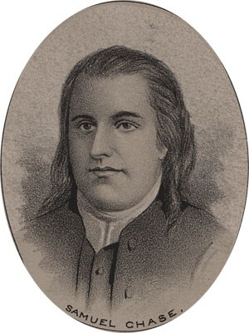  
  
by Ole Erekson, Engraver, c1876, Library of Congress

Samuel Chase was born in Maryland on the seventeenth of April 1741. He received a good classical education in Baltimore. He studied law and began practice in Annapolis. In 1774 he was selected to represent Maryland at the Continental Congress. He was re-elected to that post in 1775 and served there until 1778. In 1786 he moved to Baltimore, where two years later he was appointed chief justice of the Criminal Court of that district. He was later appointed chief justice of the state. In 1796 he was appointed a judge of the Supreme Court of the United States, an office that he filled until his death on the nineteenth of June 1811.

This broadsheet is dedicated to the 250th Anniversary Celebration of the Declaration of Independence for more information visit the National Society Sons of the American Revolution website at:  [www.sar.org](http://www.sar.org)

**Presented by: Oregon Sons of the American Revolution, www.oregonsar.org**

Copyright © 1999-2023 by the Independence Hall Association, a nonprofit organization in Philadelphia, Pennsylvania, founded in 1942. Publishing electronically as ushistory.org. On the Internet since July 4, 1995. **Source: www.ushistory.org**