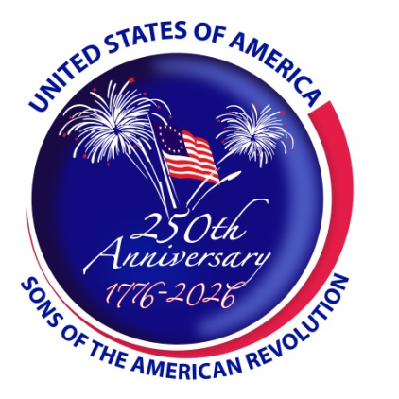  
***An America 250 SAR Program***

**FOR IMMEDIATE RELEASE**

**Nathan Boone Patriot Son of Daniel Boone Honored in Missouri**

***Ashgrove, Missouri – April 21, 2021*** *–*The Ozark Mountain Chapter Missouri SAR, held an event at the Nathan Boone Historical Site near Ash Grove, Missouri. The event was held in conjunction with the Major Nathan Boone Chapter of the General Society of the War of 1812 in the State of Missouri, who was celebrating the 10th anniversary of the chapter.

The Major Nathan Boone Chapter had a brief Anniversary Celebration in the Boone Homestead where that conducted their first meeting. Following the meeting, the attendees walked to the graves of Nathan Boone and his wife Olive (Van Bibber) Boone. The Ozark Mountain Chapter, SAR, honored Boone as a Patriot Son by placing a bronze medallion on his gravestone identifying Boone as the Son of a Patriot.

Major Nathan Boone was a militiaman in the War of 1812 seeing action in Missouri, Illinois, and Kentucky. Later he was an Indian Agent, Missouri Legislator, and prominent figure in Southwest Missouri. Nathan was the youngest child of Daniel Boone who was a captain in the militia during the American Revolution. He was credited with blazing the Wilderness Trail through the Cumberland Gap and leading thousands of pioneers across the mountains to the Boonesborough Kentucky settlement which was named for him. Boone was an essential Indian fighter as he fought in the wilderness against the British allies. In July 1776 he led a group of settlers who were able to rescue, unharmed, his daughter and two other girls who had been captured by Indians three days earlier. Daniel is best known for his exploration of the Kentucky frontier and the settlement of the area that became the state of Kentucky. Later in life he received a grant from the Spanish government for land in what would become the State of Missouri. He died in Missouri where he lived with his son Nathan Boone near Defiance, Missouri. Nathan Boone later moved to Greene County, Missouri where his homestead and grave site are located.

The event was attended by thirteen SAR members, six Color Guardsmen and seven War of 1812 members, including the Missouri SAR President, George Swales and War of 1812 President Sumner Hunnewell.

*L-R Charles McMillian, Donald Higgerson, Mel McNeal, Daniel F. Piedlow, George Swales,*

*Curtis Trent, Steve Perkins, Ken Lawrence, Joe Patton, Dan Philbrick, Dan McMurray, Sumner Hunnewell, J. Howard Fisk, and Daniel J. Piedlow (not in photo).*

*Wreath, muskets, sword, and gravestone of Nathan Boone*

**About the America250 SAR Committee**

The America 250 SAR Committee works at the national, state, and local levels to promote the commemoration of the 250th Anniversary of the American Revolution and the formation of the United States. It develops educational programs, maintains a list of events, publishes articles and booklets, and publicizes the anniversary through media, education, and government contacts. The committee also helps the International Sons of the American Revolution Societies of Canada, France, Germany, Mexico, Spain, Switzerland, and the United Kingdom in planning their special celebrations.

Learn more at <http://www.sar.org>

**Local Press contact:**

J. Howard Fisk

(417) 862-5285

jhoward@fisk.limo

**NOTES TO MEDIA AND PRESS MATERIALS:**Photos and video available via Dropbox or available upon email request.

###